**ASSIGNMENT 1**

**1.EVEN OR ODD**

**Aim:** Write a program to check whether a number is odd or even.

Code:

import java.util.Scanner;

class oddeven {

public static void main(String[] args) {

Scanner reader=new Scanner(System.in);

System.out.print("Enter a number:");

int num=reader.nextInt();

if(num%2==0)

System.out.print("Even number");

else

System.out.print(" Odd number");

}

}

Output

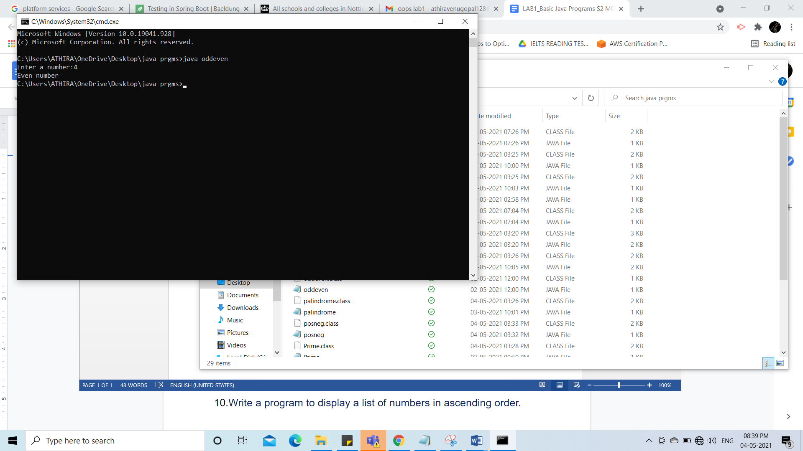

2.LARGEST OF 3 NUMBERS

Aim: Write a program to find the largest of three numbers.

Code:

import java.util.Scanner;

class biggest {

public static void main(String[] args) {

Scanner reader=new Scanner(System.in);

System.out.print("Enter first number:");

int num1=reader.nextInt();

System.out.print("Enter second number:");

int num2=reader.nextInt();

System.out.print("Enter third number:");

int num3=reader.nextInt();

if(num1>num2&&num1>num3)

System.out.print("The number "+num1+" is bigger");

else if(num2>num1&&num2>num3)

System.out.print("The number "+num2+" is bigger");

else

System.out.print("The number "+num3+" is bigger");

}

}

Output

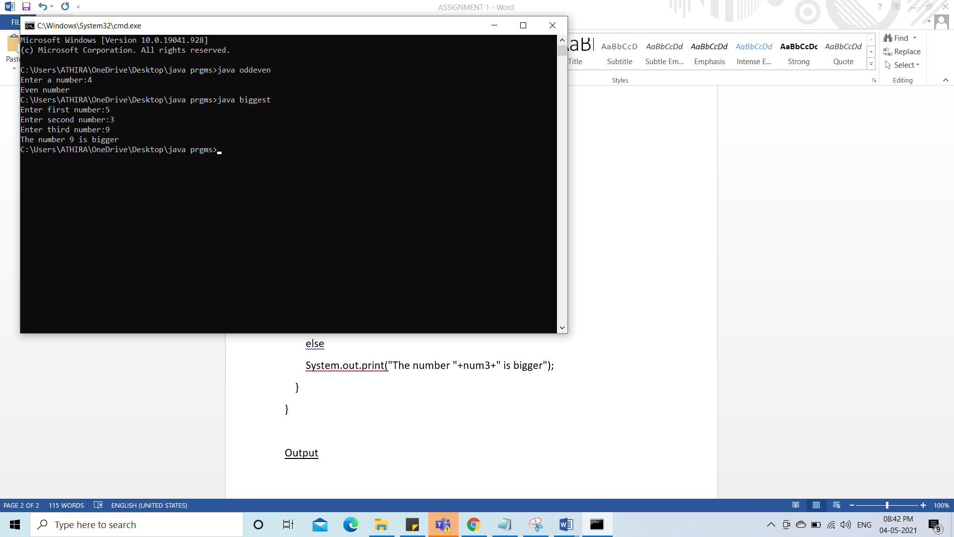

3.POSITIVE OR NEGATIVE

Aim: Write a program to check whether a given number is positive or negative using  ternary operator. ( **?:**)

Code:

import java.util.Scanner;

class posneg {

public static void main(String[] args) {

Scanner reader=new Scanner(System.in);

System.out.print("Enter a number:");

int num=reader.nextInt();

String res=(num>0) ? "Positive":(num<0)?"Negative":"Zero";

System.out.println("The number "+num+" is a "+res+" number");

}

}

Output

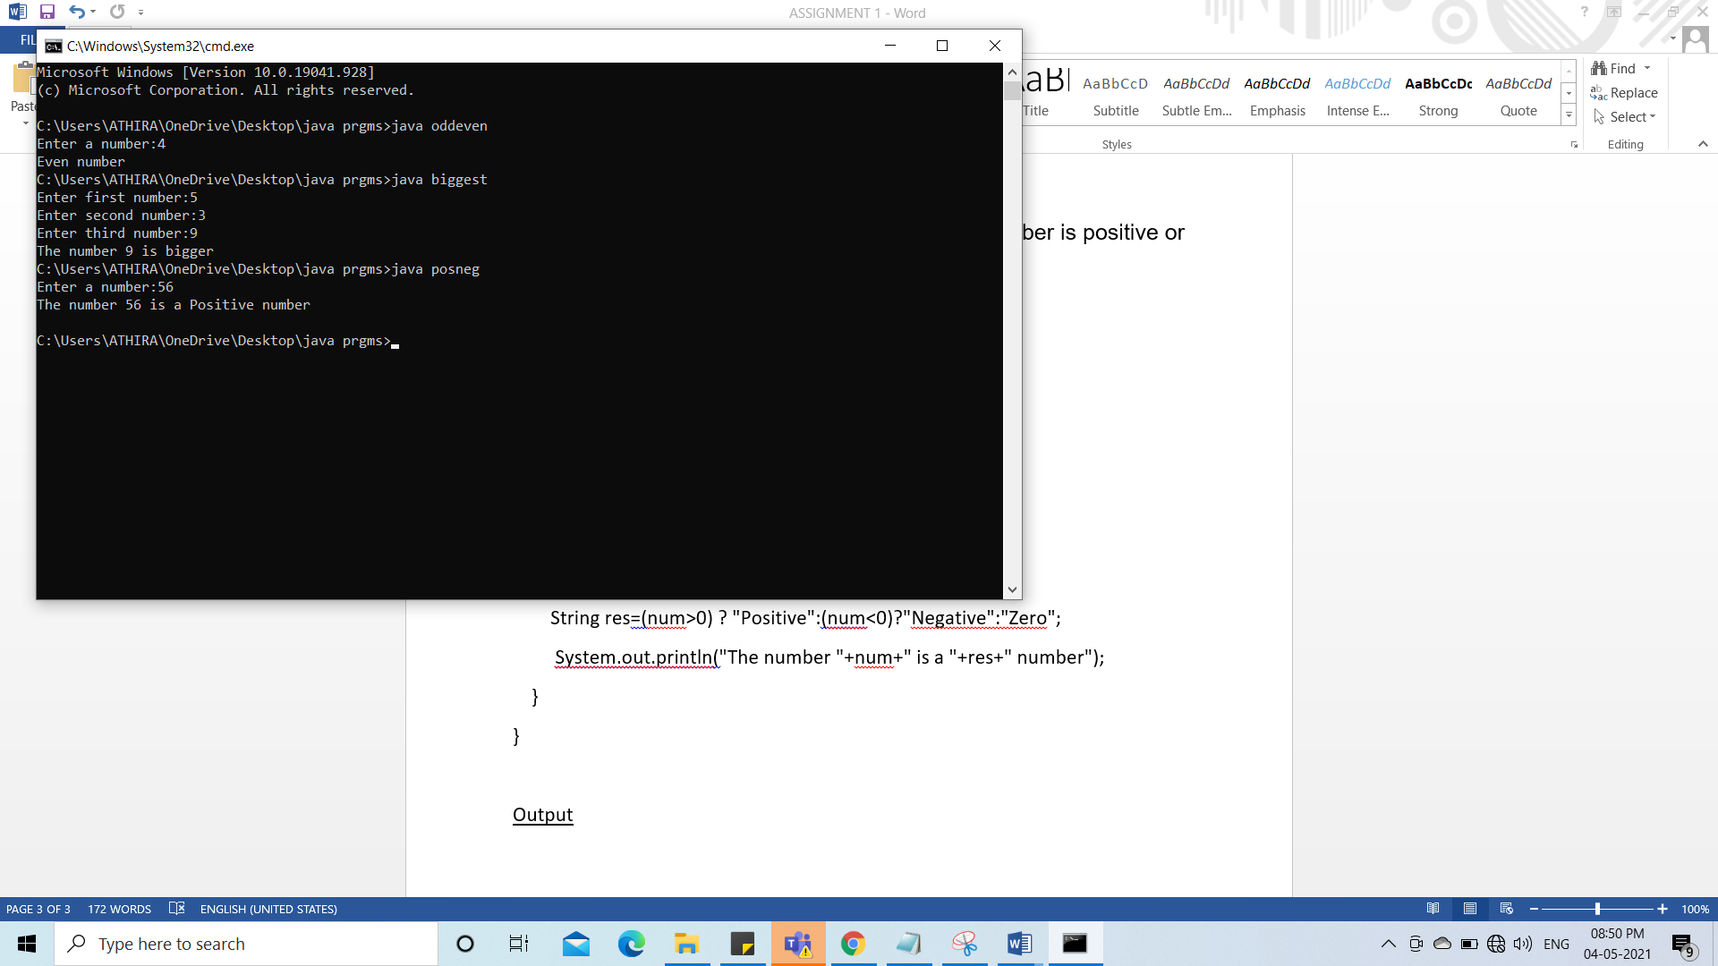

4.FACTORIAL

Aim: Write a program to find the factorial of a number.

Code:

import java.util.Scanner;

class factorial {

public static void main(String[] args) {

Scanner reader=new Scanner(System.in);

System.out.print("Enter a number:");

int num=reader.nextInt();

int i,fact=1;

for(i=1;i<=num;i++){

fact=fact*i;

}

System.out.println("Factorial of "+num+" is: "+fact);

}

}

Output:

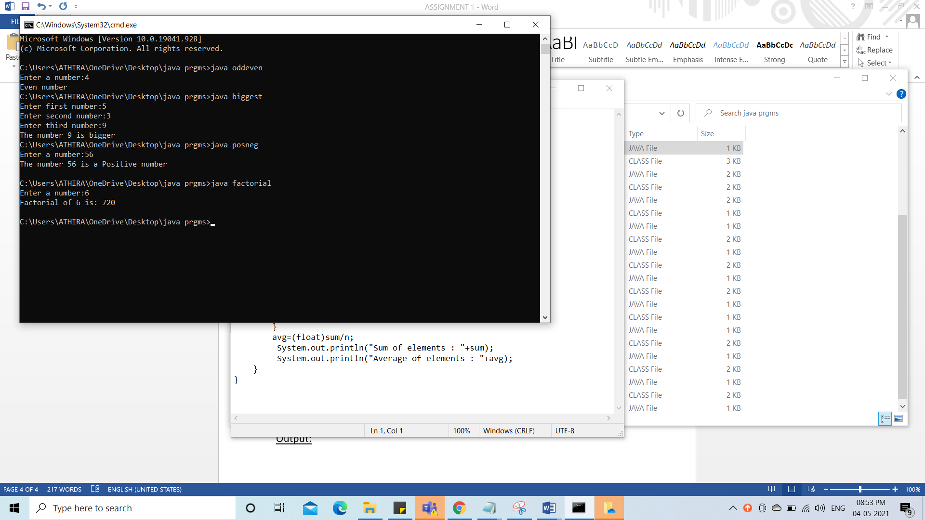

5.PALINDROME

Aim: Write a program to check whether a number is palindrome or not.

Code:

import java.util.Scanner;

class palindrome {

public static void main(String[] args) {

Scanner reader=new Scanner(System.in);

System.out.print("Enter a number:");

int num=reader.nextInt();

int temp=num;

int rev=0;

while(num!=0)

{

int a=num%10;

rev=rev*10+a;

num=num/10;

}

System.out.println("Reversed number is "+rev);

if(temp==rev)

System.out.println("The number "+temp+" is palindrome");

else

System.out.println("The number "+temp+" is not a palindrome");

}

}

Output:

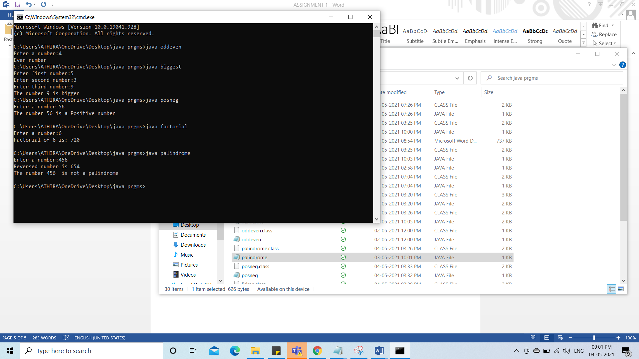

6.NUMBER NAME

Aim: Write a program to display the Number Name of a number between 0 and 9 (use **switch** statement).

Code:

import java.util.Scanner;

class numname {

public static void main(String[] args) {

Scanner reader=new Scanner(System.in);

System.out.print("Enter a numberbetween 0 and 9:");

int num=reader.nextInt();

switch(num)

{

case 1:

System.out.println("The number name of "+num+" is one");

break;

case 2:

System.out.println("The number name of "+num+" is two");

break;

case 3:

System.out.println("The number name of "+num+" is three");

break;

case 4:

System.out.println("The number name of "+num+" is four");

break;

case 5:

System.out.println("The number name of "+num+" is five");

break;

case 6:

System.out.println("The number name of "+num+" is six");

break;

case 7:

System.out.println("The number name of "+num+" is seven");

break;

case 8:

System.out.println("The number name of "+num+" is eight");

break;

case 9:

System.out.println("The number name of "+num+" is nine");

break;

default:

System.out.println("Invalid entry");

}

}

}

Output:

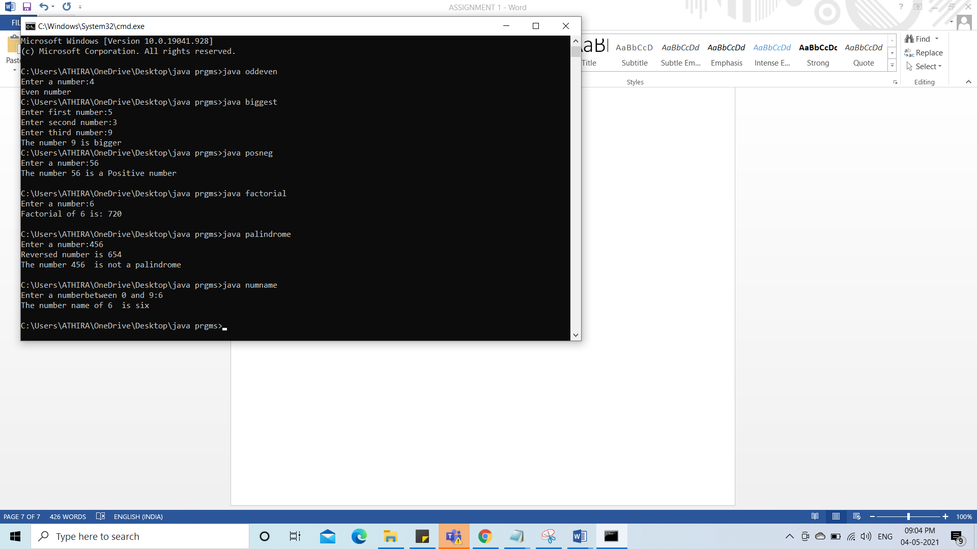

**7.PRIME NUMBER**

Aim: Write a program to display prime number upto a limit

Code:

import java.util.Scanner;

class Prime {

public static void main(String[] args) {

Scanner reader=new Scanner(System.in);

System.out.print("Enter a limit:");

int num=reader.nextInt();

System.out.println("Prime numbers are: ");

for(int i=1;i<=num;i++)

{

int p=0;

for(int j=1;j<=i;j++)

{

if(i%j==0)

p++;

}

if(p==2)

System.out.print(" "+i);

}

}

}

Output:

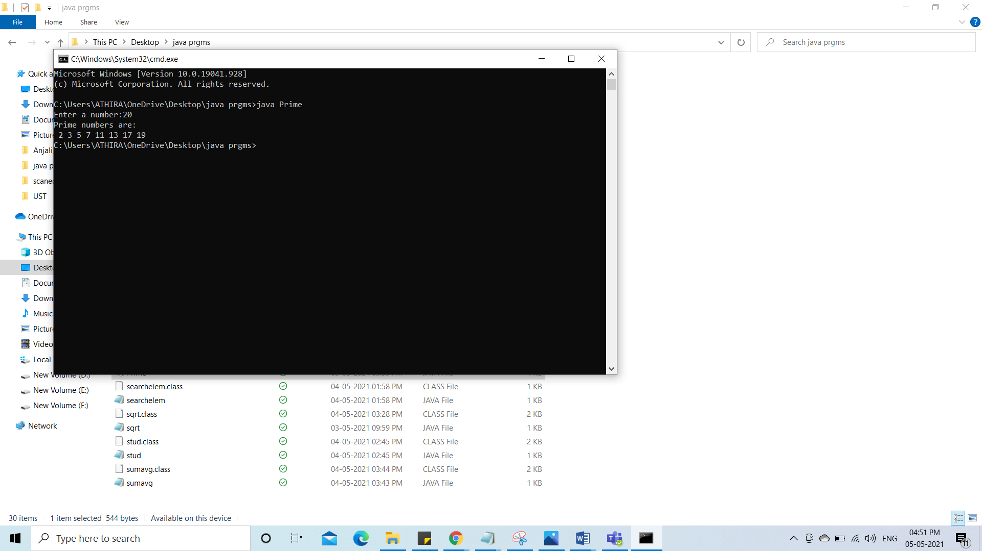

**8.LARGEST IN A LIST**

Aim: Write a program to find the largest number in a list

Code:

import java.util.Scanner;

class arraylarge {

public static void main(String[] args) {

int n;

Scanner reader=new Scanner(System.in);

System.out.print("Enter number of elements:");

n=reader.nextInt();

int num[]=new int[n];

System.out.print("Enter array elements:");

for(int i=0;i<n;i++)

{

num[i]=reader.nextInt();

}

int max=num[0];

for(int i=0;i<n;i++)

{

if(max<num[i])

{

max=num[i];

}

}

System.out.print("Largest value in array is "+max);

}

}

Output:

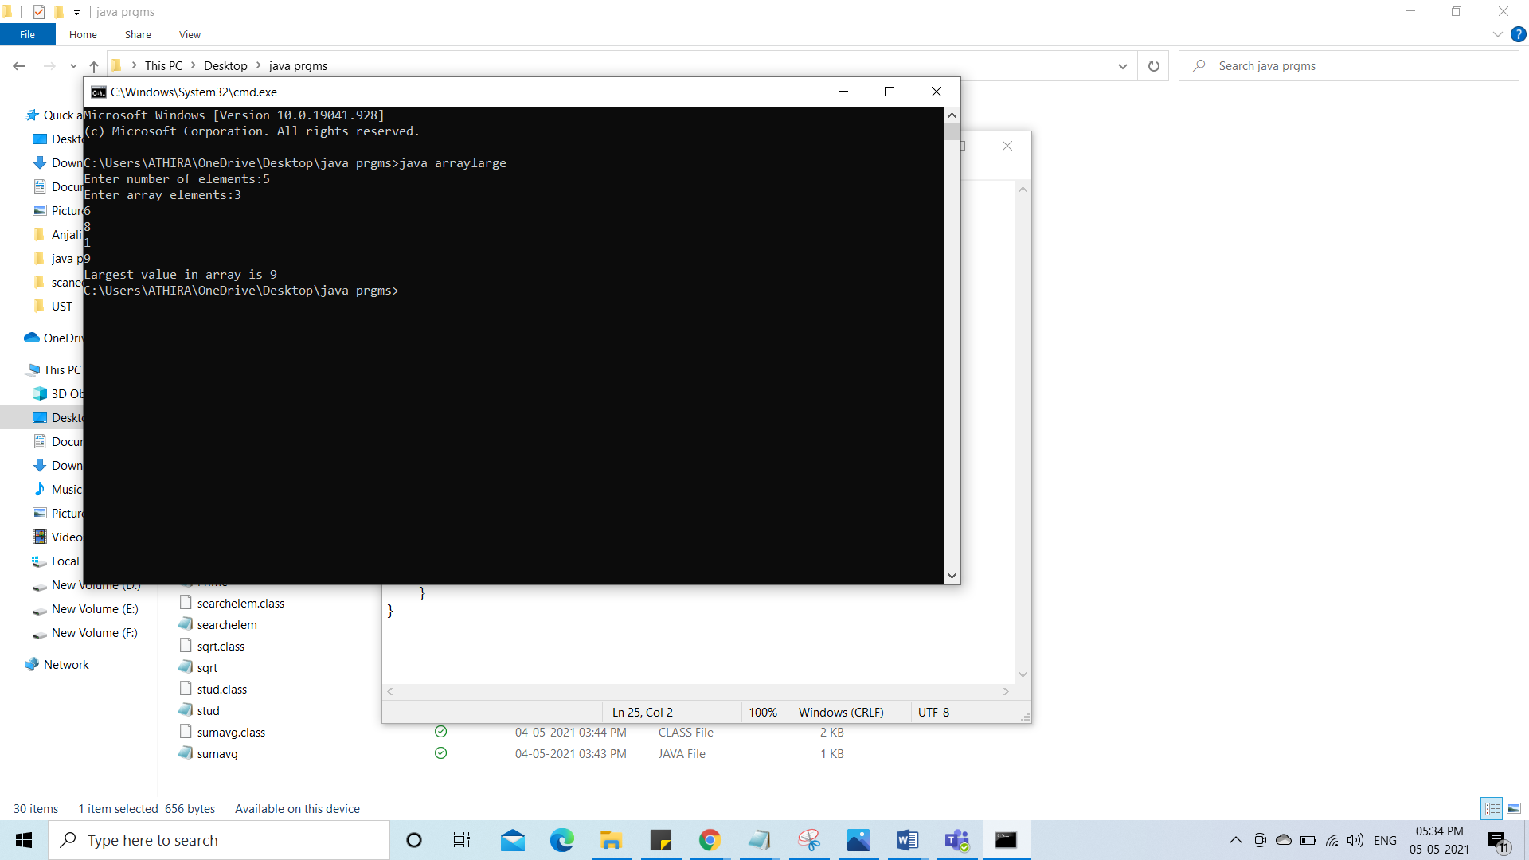

**9.SUM AND AVERAGE OF N NUMBERS**

**Aim:** Write a program to find sum and average on n numbers

Code:

import java.util.Scanner;

class sumavg {

public static void main(String[] args) {

int n,sum=0;

float avg=0;

Scanner reader=new Scanner(System.in);

System.out.print("Enter number of elements:");

n=reader.nextInt();

int num[]=new int[n];

System.out.print("Enter array elements:");

for(int i=0;i<n;i++)

{

num[i]=reader.nextInt();

}

for(int i=0;i<n;i++)

{

sum=sum+num[i];

}

avg=(float)sum/n;

System.out.println("Sum of elements : "+sum);

System.out.println("Average of elements : "+avg);

}

}

Output:

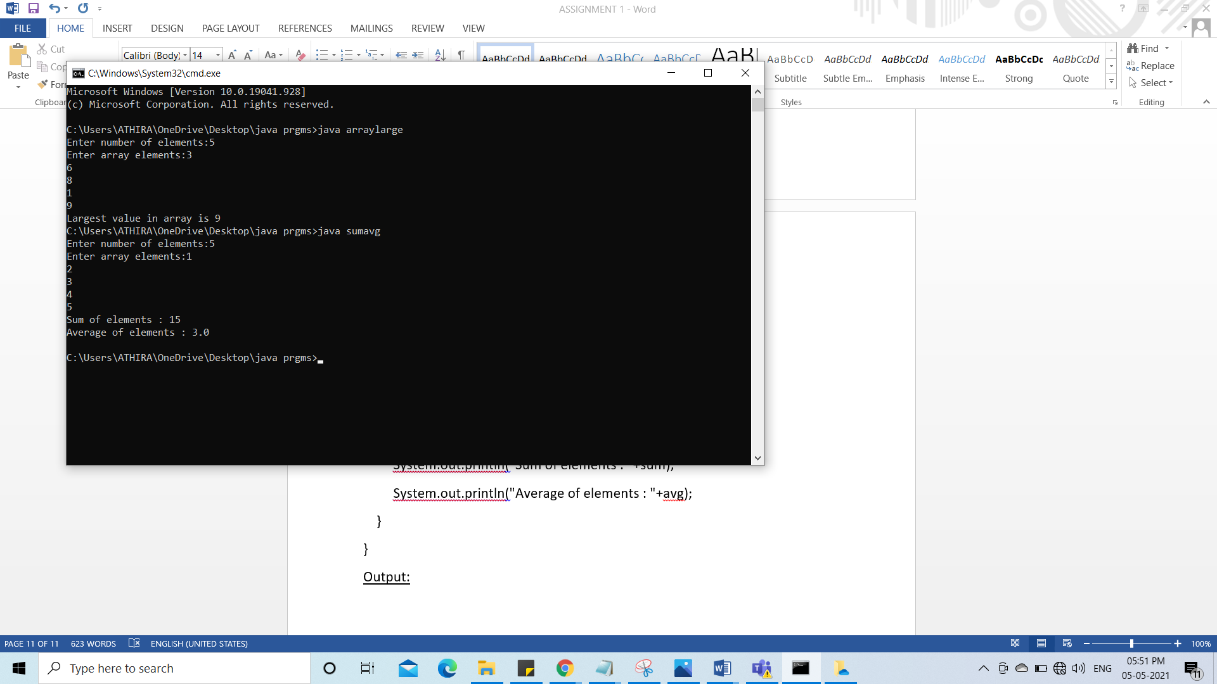

**10:NUMBERS IN ASCENDING ORDER**

**Aim:** Write a program to display a list of numbers in ascending order

Code:

import java.util.Scanner;

class arrayasc {

public static void main(String[] args) {

int n, temp;

Scanner reader = new Scanner(System.in);

System.out.print("Enter number of elements:");

n = reader.nextInt();

int a[] = new int[n];

System.out.println("Enter the elements:");

for (int i = 0; i < n; i++)

{

a[i] = reader.nextInt();

}

for (int i = 0; i < n; i++)

{

for (int j = i + 1; j < n; j++)

{

if (a[i] > a[j])

{

temp = a[i];

a[i] = a[j];

a[j] = temp;

}

}

}

System.out.print("Ascending Order:");

for (int i = 0; i < n; i++)

{

System.out.print(a[i] + " ");

}

}

}

Output:

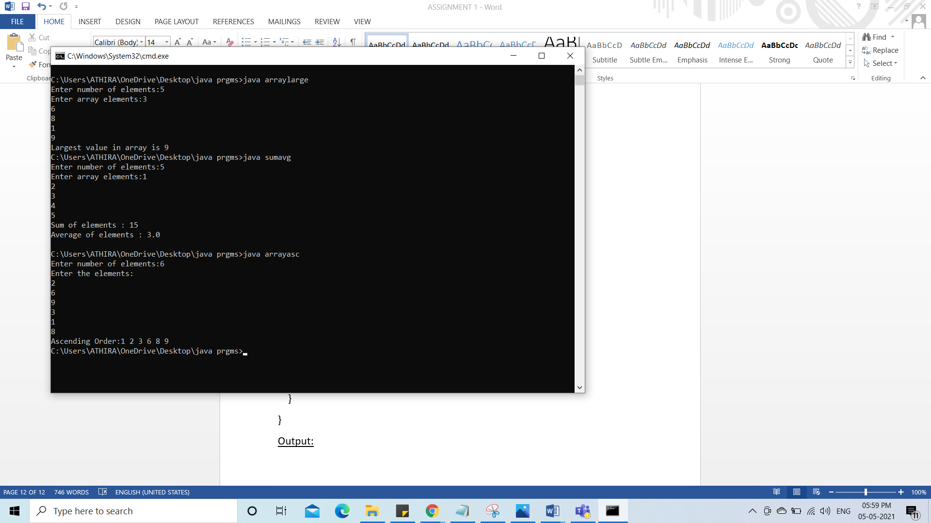

**11.** matrix addition.

**Aim**: Read 2 matrices from the console and perform matrix addition.

**Code:**

**import java.util.Scanner;**

**class matadd {**

**public static void main(String[] args) {**

**int row1,col1,i,j;**

**Scanner reader = new Scanner(System.in);**

**System.out.print("Enter number of rows:");**

**row1 = reader.nextInt();**

**System.out.print("Enter number of colums:");**

**col1 = reader.nextInt();**

**int a[][] = new int[row1][col1];**

**int b[][]=new int[row1][col1];**

**int c[][]=new int[row1][col1];**

**System.out.println("Enter the elements of MAT1:");**

**for ( i = 0; i < row1; i++)**

**{**

**for(j=0; j<col1; j++)**

**{**

**a[i][j] = reader.nextInt();**

**}**

**}**

**System.out.print("MATRIX 1 :\n");**

**for ( i = 0; i < row1; i++)**

**{**

**for (j =0; j < col1; j++)**

**{**

**System.out.print(a[i][j]+" ");**

**}**

**System.out.println();**

**}**

**System.out.println("Enter the elements of MAT2:");**

**for ( i = 0; i < row1; i++)**

**{**

**for(j=0; j<col1; j++)**

**{**

**b[i][j] = reader.nextInt();**

**}**

**}**

**System.out.print("MATRIX 2:\n");**

**for (i = 0; i < row1; i++)**

**{**

**for (j =0; j< col1;j++)**

**{**

**System.out.print(b[i][j]+" ");**

**}**

**System.out.println();**

**}**

**for(i=0;i<row1;i++)**

**{**

**for(j=0;j<col1;j++)**

**{**

**c[i][j]=a[i][j]+b[i][j];**

**}**

**}**

**System.out.print("\nSUM:\n");**

**for (i = 0; i <row1; i++)**

**{**

**for (j =0;j<col1;j++)**

**{**

**System.out.print(c[i][j]+" ");**

**}**

**System.out.println();**

**}**

**}**

**}**

Output:

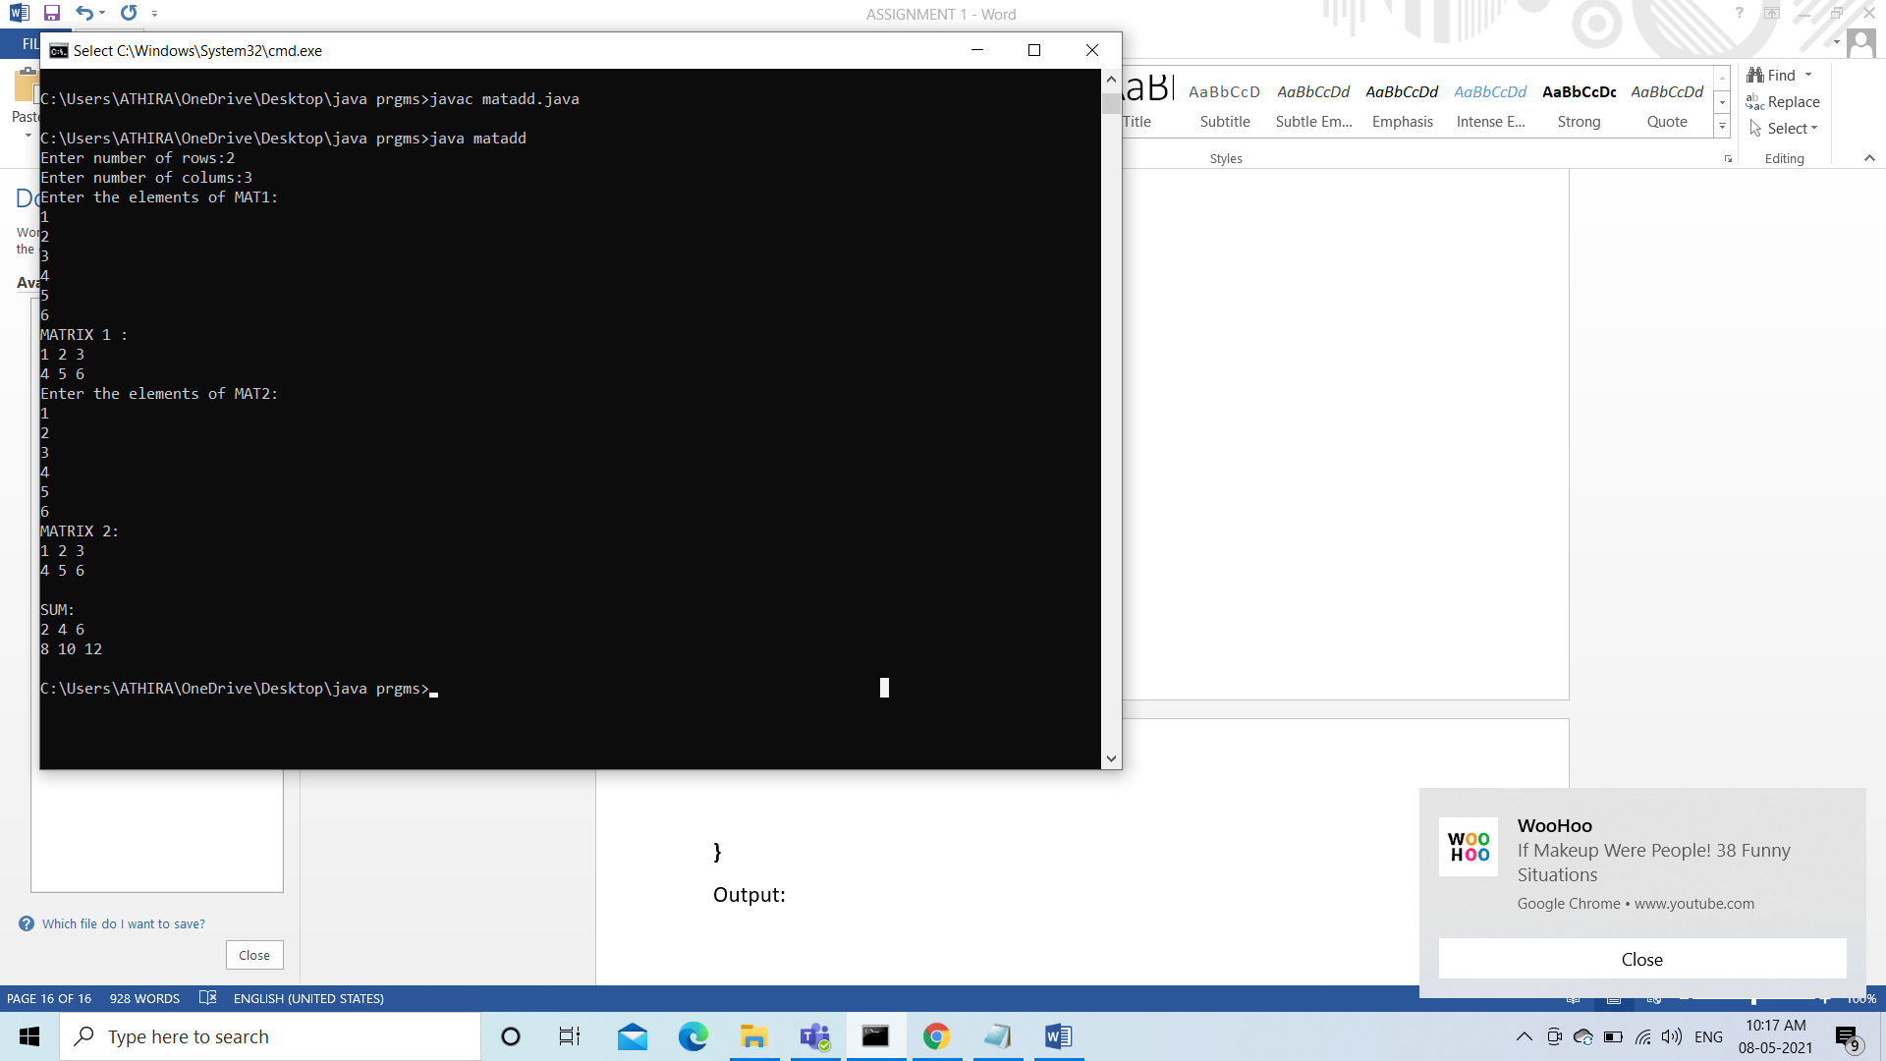

12.Matrix Symmetric

Aim: Read a matrix from the console and check whether it is symmetric or not.

Code:

import java.util.Scanner;

class symmat {

public static void main(String[] args) {

int row1,col1,i,j,f=1;

Scanner reader = new Scanner(System.in);

System.out.print("Enter number of rows:");

row1 = reader.nextInt();

System.out.print("Enter number of colums:");

col1 = reader.nextInt();

int a[][] = new int[row1][col1];

int b[][]=new int[row1][col1];

System.out.println("Enter the elements of MAT1:");

for ( i = 0; i < row1; i++)

{

for(j=0; j<col1; j++)

{

a[i][j] = reader.nextInt();

}

}

System.out.print("MATRIX 1 :\n");

for ( i = 0; i < row1; i++)

{

for (j =0; j < col1; j++)

{

System.out.print(a[i][j]+" ");

}

System.out.println();

}

if(row1==col1)

{

for (i = 0; i < row1; i++)

{

for (j =0; j< col1;j++)

{

b[i][j]=a[j][i];

}

}

System.out.print("TRANSPOSE:\n");

for ( i = 0; i < row1; i++)

{

for (j =0; j < col1; j++)

{

System.out.print(b[i][j]+" ");

}

System.out.println();

}

}

for(i=0;i<row1;i++)

{

for(j=0;j<col1;j++)

{

if(a[i][j]!=b[i][j])

{

f=0;

break;

}

}

}

if(f==0)

System.out.print("The matrix is not symmetric");

else System.out.print("The matrix is symmetrix");

}

}

Output:

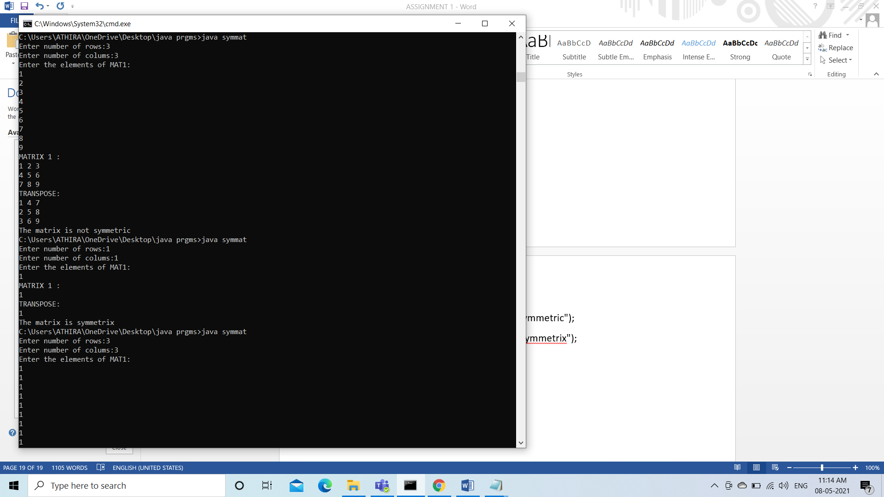

13.Search an element

Aim: Search an element in an array.

Code:

import java.util.Scanner;

class searchelem {

public static void main(String[] args) {

int n,c=0;

Scanner reader=new Scanner(System.in);

System.out.print("Enter number of elements:");

n=reader.nextInt();

int num[]=new int[n];

System.out.println("Enter array elements:");

for(int i=0;i<n;i++)

{

num[i]=reader.nextInt();

}

System.out.print("Enter the element to be searched: ");

int elem=reader.nextInt();

for(int i=0;i<n;i++)

{

if(elem==num[i])

{

c++;

}

}

if(c==0)

System.out.print("Element "+elem+" is not found ");

else System.out.print("Element " +elem+" is found "+c+” times” );

}

}

Output:

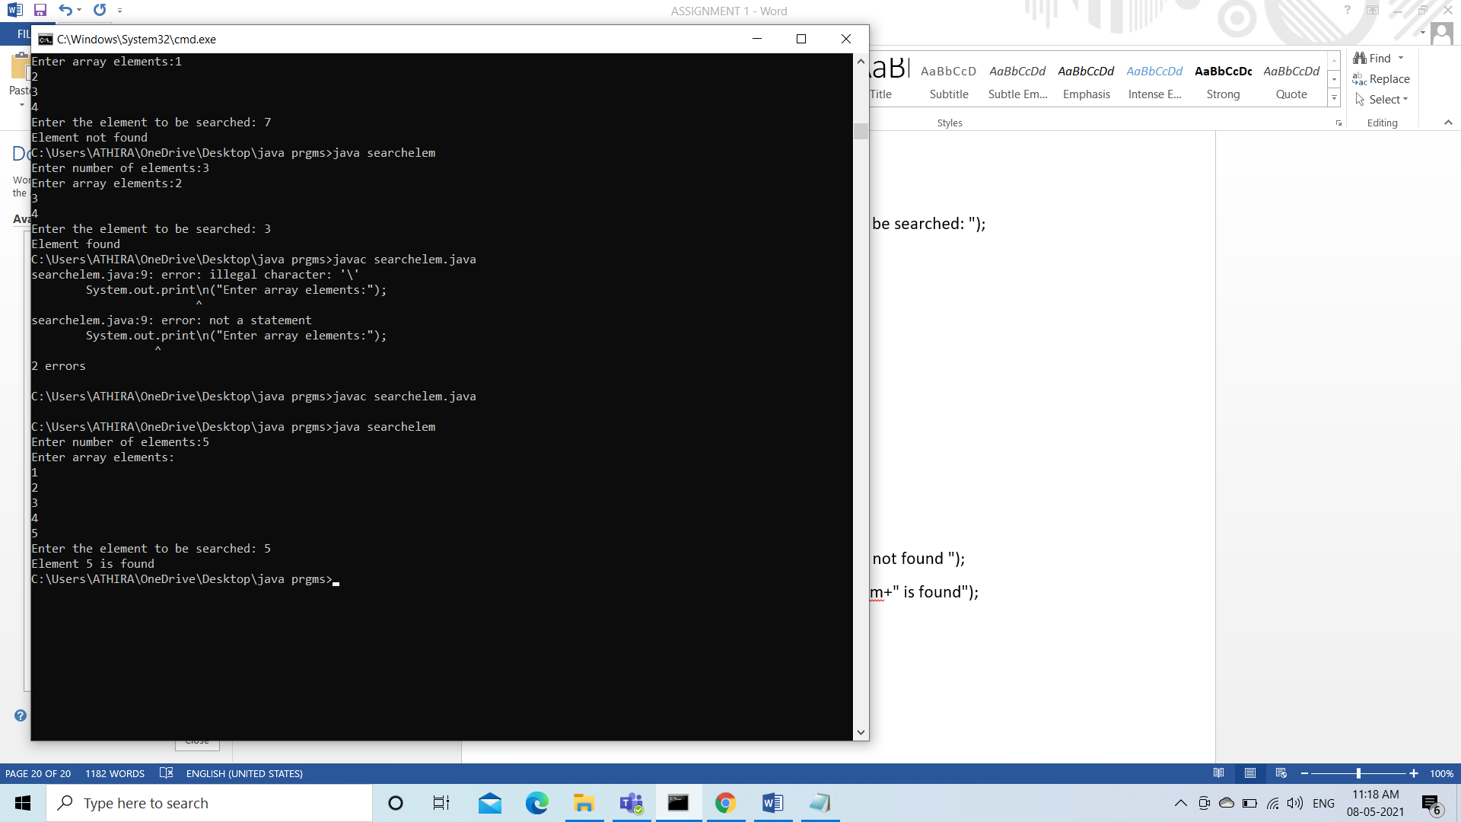

14.Student details

Aim: Program to create a class Student having attributes name, roll, branch, mark, grade of datatype String, integer, array of character, double/float, character respectively. Read the student information and display the same.

Code:

import java.util.Scanner;

class stud {

public static void main(String[] args) {

String name;

int roll,i;

char[] branch;

double mark;

char grade;

Scanner reader=new Scanner(System.in);

System.out.print("Enter student name:");

name= reader.nextLine();

System.out.print("Enter roll number:");

roll=reader.nextInt();

System.out.print("Enter branch:");

branch=reader.next().toCharArray();

System.out.print("Enter student mark:");

mark=reader.nextDouble();

System.out.print("Enter student grade:");

grade=reader.next().charAt(0);

System.out.println("\n\nStudent details:\nName: "+name+"\nRoll number: "+roll+

"\nBranch name: ");

for(i=0;i<branch.length;i++)

System.out.print(branch[i]);

System.out.print("\nMArk : "+mark+"\nGrade: "+grade);

}

}

Output:

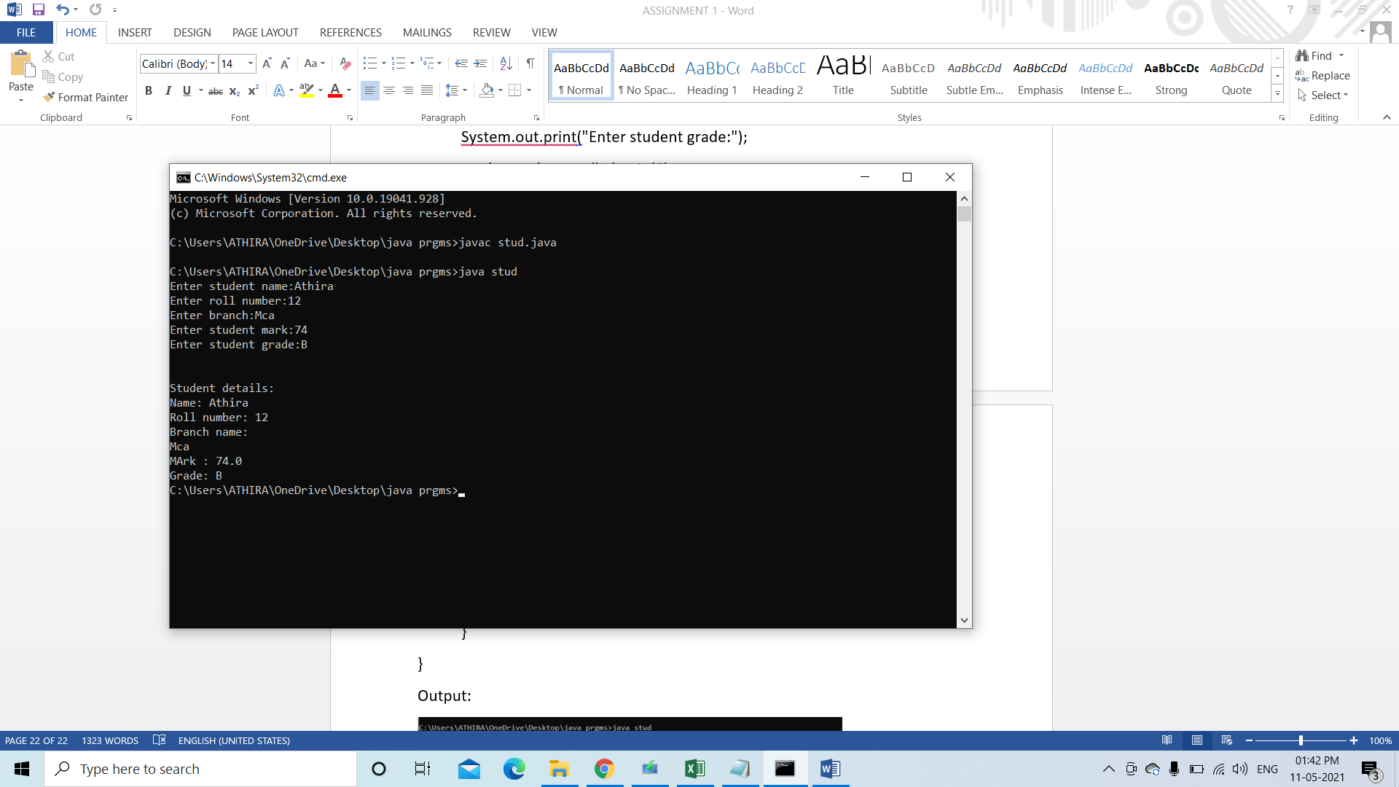

14.Circle

Aim: Create a class Circle with fields x co-ordinate, y co-ordinate and radius , Also having member functions area() and circumference(). Write a program to compute the circumference and area of the circle when user enters the centre and radius of the circle.

Code:

20.Area overload

Aim: Area of different shapes using overloaded functions

Code:

import java.util.Scanner;  
public class shapearea {  
 void area(float x){  
 System.*out*.print("\nThe area of square is "+Math.*pow*(x,2)+" sq units\n");  
 }  
 void area(float x,float y){  
 System.*out*.print("The area of rectangle is "+x*y+" sq units\n");  
 }  
 void area(double x){  
 double z=3.14*x*x;  
 System.*out*.print("The area of the circle is "+z+" sq units\n" );  
 }  
}  
class overload{  
 public static void main(String args[]){  
 float s,l,b;  
 double r;  
 Scanner reader=new Scanner(System.*in*);  
 shapearea obj=new shapearea();  
 System.*out*.print("Enter the side of square: ");  
 s=reader.nextFloat();  
 System.*out*.print("Enter the length of rectangle: ");  
 l=reader.nextFloat();  
 System.*out*.print("Enter the breadth of rectangle: ");  
 b=reader.nextFloat();  
 System.*out*.print("Enter the radius of circle: ");  
 r=reader.nextDouble();  
 obj.area(s);  
 obj.area(l,b);  
 obj.area(r);  
 }  
}

OUTPUT:

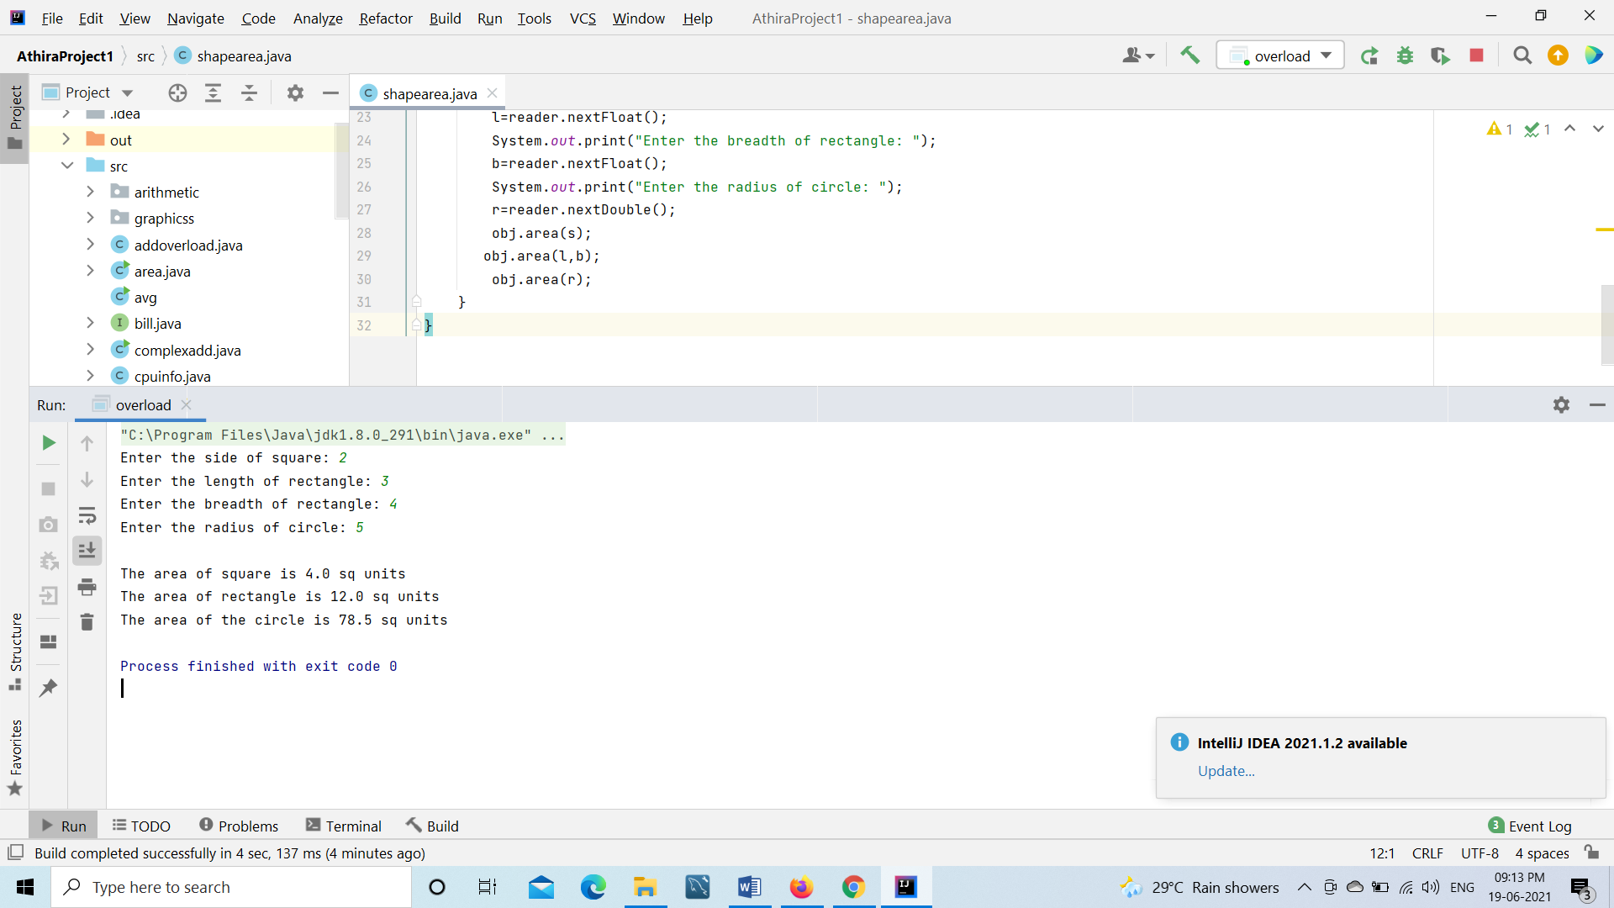

21.ADD OVERLOAD

Aim:

Write a Java program to perform addition on 2 integers, 3 integers and 2 float values using overloaded functions.

Code:

import java.util.Scanner;  
  
public class addoverload {  
 void add(int x,int y){  
 System.*out*.print("\n" +  
 "Sum of 2 integers is "+(x+y)+" \n");  
 }  
 void add(int x,int y, int z){  
  
 System.*out*.print("Sum of 3 integers are "+(x+y+z)+" \n");  
 }  
 void add(float x,float y){  
 System.*out*.print("Sum of 2 float values is "+(x+y)+" \n" );  
 }  
 }  
 class overloadfn{  
 public static void main(String args[]){  
 int a,b,c,d,e;  
 float m,n;  
 Scanner reader=new Scanner(System.*in*);  
 addoverload obj=new addoverload();  
 System.*out*.print("Enter two integers: ");  
 a=reader.nextInt();  
 b=reader.nextInt();  
 System.*out*.print("Enter three integers: ");  
 c=reader.nextInt();  
 d=reader.nextInt();  
 e=reader.nextInt();  
 System.*out*.print("Enter two float values: ");  
 m=reader.nextFloat();  
 n=reader.nextFloat();  
 obj.add(a,b);  
 obj.add(c,d,e);  
 obj.add(m,n);  
 }  
 }

Output:

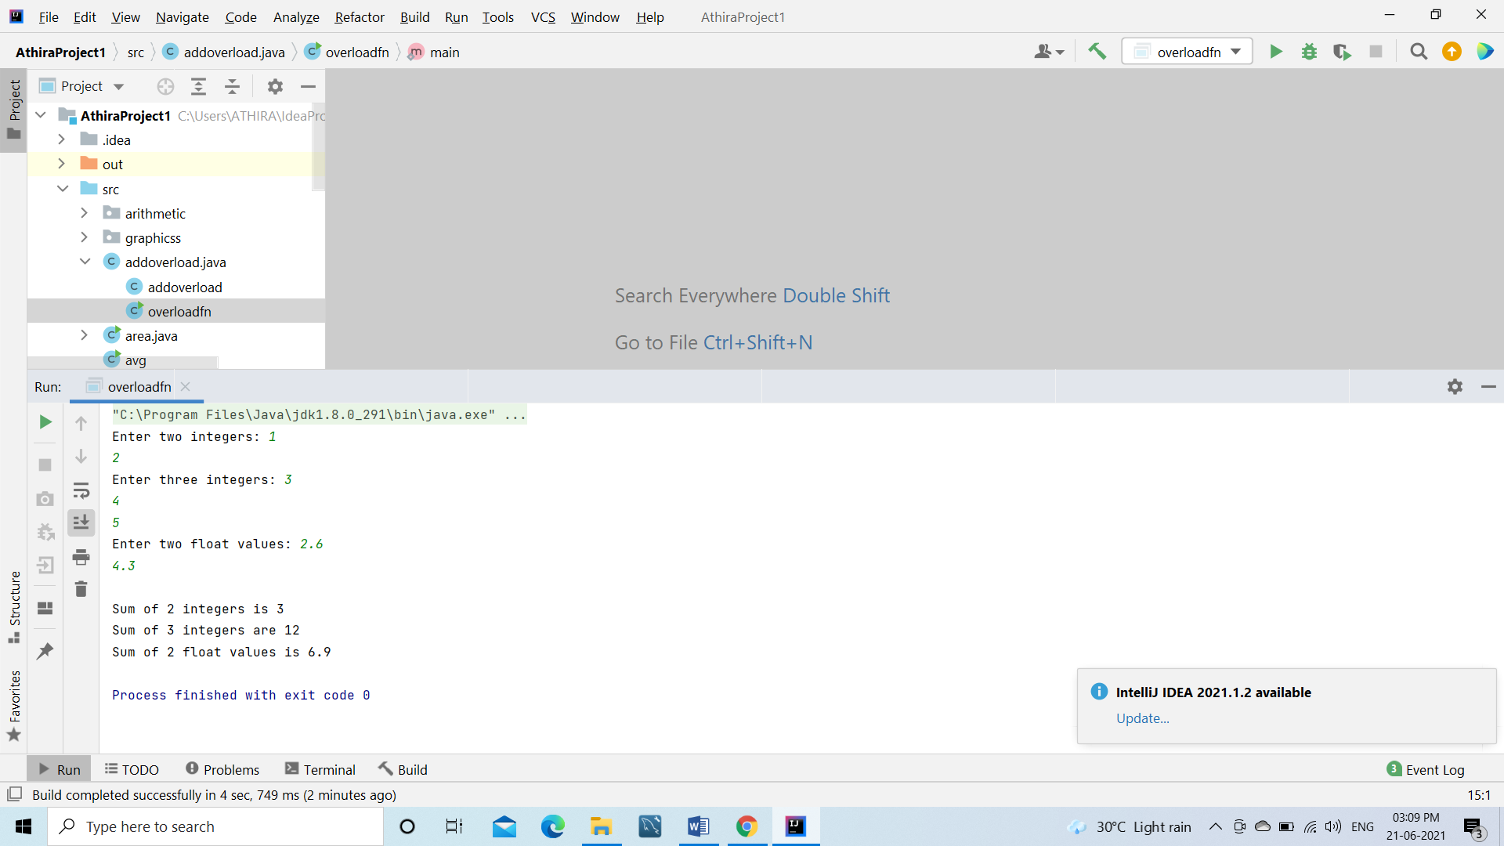

22. Class employee

Aim: Create a class ‘Employee’ with data members Empid, Name, Salary, Address and constructors to initialize the data members. Create another class ‘Teacher’ that inherits the properties of class Employee and contains its own data members department, Subjects taught and constructors to initialize these data members and also include a display function to display all the data members. Use an array of objects to display details of N teachers.

Code:

import java.util.Scanner;  
  
public class employee {  
 int empid;  
 String name;  
 float salary;  
 String address;  
  
 public employee() {  
 empid = 0;  
 name = " ";  
 salary = 0;  
 address = " ";  
 }  
  
 public void input() {  
 Scanner reader = new Scanner(System.*in*);  
 System.*out*.print("Enter the employee number : ");  
 empid = reader.nextInt();  
 System.*out*.print("Enter the employee name : ");  
 name = reader.next();  
 System.*out*.print("Enter the employee salary : ");  
 salary = reader.nextFloat();  
 System.*out*.print("Enter the employee address : ");  
 address = reader.next();  
 }  
  
}  
class teacher extends employee {  
 String dept,sub;  
 *//String sub[];* public teacher(){  
 dept=" ";  
 sub=" ";  
  
 }  
 public void data() {  
 *//int m;* Scanner reader = new Scanner(System.*in*);  
 System.*out*.print("Enter the department : ");  
 dept = reader.next();  
 *//System.out.print("Enter the number of subjects: ");  
 //m=reader.nextInt();  
 //String[] sub=new String[50];* System.*out*.print("Enter the subject taught : ");  
 sub=reader.next();  
 *//for (int i = 0; i<m; i++){  
 // sub[i] = reader.nextLine();  
 // }* }  
 public void output() {  
 System.*out*.println("Employee id = " + empid);  
 System.*out*.println("Employee name = " + name);  
 System.*out*.println("Employee salary = " + salary);  
 System.*out*.println("Employee address = " + address);  
 System.*out*.println("Employee department = " + dept);  
 System.*out*.println("Subject taught = "+sub);  
 *//for (int i=0; i<sub.length; i++) {  
 // System.out.println(sub[i]+" ");  
 //}* }  
  
 public static void main(String[] args) {  
 int n;  
 Scanner reader = new Scanner(System.*in*);  
 System.*out*.print("Enter the number of Employees: ");  
 n = reader.nextInt();  
 teacher t[] = new teacher[n];  
  
 for (int i = 0; i < n; i++) {  
 t[i] = new teacher();  
 t[i].input();  
 t[i].data();  
 System.*out*.print("\n");  
 }  
  
 System.*out*.println("EMPLOYEE DETAILS: ");  
 for (int i = 0; i < n; i++) {  
 t[i].output();  
 System.*out*.print("\n");  
 }  
 }  
}

Output:

23.Class person

Aim: Create a class ‘Person’ with data members Name, Gender, Address, Age and a constructor to initialize the data members and another class ‘Employee’ that inherits the properties of class Person and also contains its own data members like Empid, Company_name, Qualification, Salary and its own constructor. Create another class ‘Teacher’ that inherits the properties of class Employee and contains its own data members like Subject, Department, Teacher id and also contains constructors and methods to display the data members. Use an array of objects to display details of N teachers.

Code:

import java.util.Scanner;  
public class person {  
 String name,gender,address;  
 int age;  
 public person(){  
 name=" ";  
 gender=" ";  
 address=" ";  
 age=0;  
 }  
 public void pinput(){  
 Scanner reader=new Scanner(System.*in*);  
 System.*out*.print("\nEnter name: ");  
 name=reader.next();  
 System.*out*.print("Enter gender :");  
 gender=reader.next();  
 System.*out*.print("Enter address: ");  
 address=reader.next();  
 System.*out*.print("Enter the age: ");  
 age=reader.nextInt();  
 }  
}  
 class Employee extends person{  
 int empid;  
 String comp_name,qualification;  
 float sal;  
 public Employee(){  
 empid=0;  
 comp_name=" ";  
 qualification=" ";  
 sal=0;  
 }  
 public void einput(){  
 Scanner reader=new Scanner(System.*in*);  
 System.*out*.print("Enter the employee id: ");  
 empid=reader.nextInt();  
 System.*out*.print("Enter company name: ");  
 comp_name=reader.next();  
 System.*out*.print("Enter qualification: ");  
 qualification=reader.next();  
 System.*out*.print("Enter salary: ");  
 sal=reader.nextFloat();  
 }  
}  
class Teacher extends Employee{  
 String subject,dept;  
 int tid;  
 public Teacher(){  
 subject=" ";  
 dept=" ";  
 tid=0;  
 }  
 public void tinput(){  
 Scanner reader=new Scanner(System.*in*);  
 System.*out*.print("Enter subject: ");  
 subject=reader.next();  
 System.*out*.print("Enter department: ");  
 dept=reader.next();  
 System.*out*.print("Enter teacher id: ");  
 tid=reader.nextInt();  
  
 }  
 public void output(){  
 System.*out*.println("\nNAME: "+name);  
 System.*out*.println("GENGER: "+gender);  
 System.*out*.println("ADDRESS: "+address);  
 System.*out*.println("AGE: "+age);  
 System.*out*.println("EMPLOYEE ID: "+empid);  
 System.*out*.println("COMPANY NAME: "+comp_name);  
 System.*out*.println("QUALIFICATION: "+qualification);  
 System.*out*.println("SALARY: "+sal);  
 System.*out*.println("SUBJECT: "+subject);  
 System.*out*.println("DEPARTMENT: "+dept);  
 System.*out*.println("TEACHER ID: "+tid+"\n");  
 }  
  
 public static void main(String[] args) {  
 int n;  
 Scanner reader = new Scanner(System.*in*);  
 System.*out*.print("Enter the limit: ");  
 n = reader.nextInt();  
 Teacher t[] = new Teacher[n];  
 for (int i = 0; i < n; i++) {  
 t[i] = new Teacher();  
 t[i].pinput();  
 System.*out*.print("\n");  
 t[i].einput();  
 System.*out*.print("\n");  
 t[i].tinput();  
 }  
 for (int i=0;i<n;i++){  
 System.*out*.print("\nEMPLOYEE DETAILS: ");  
 t[i].output();  
 }  
 }  
}

Output:

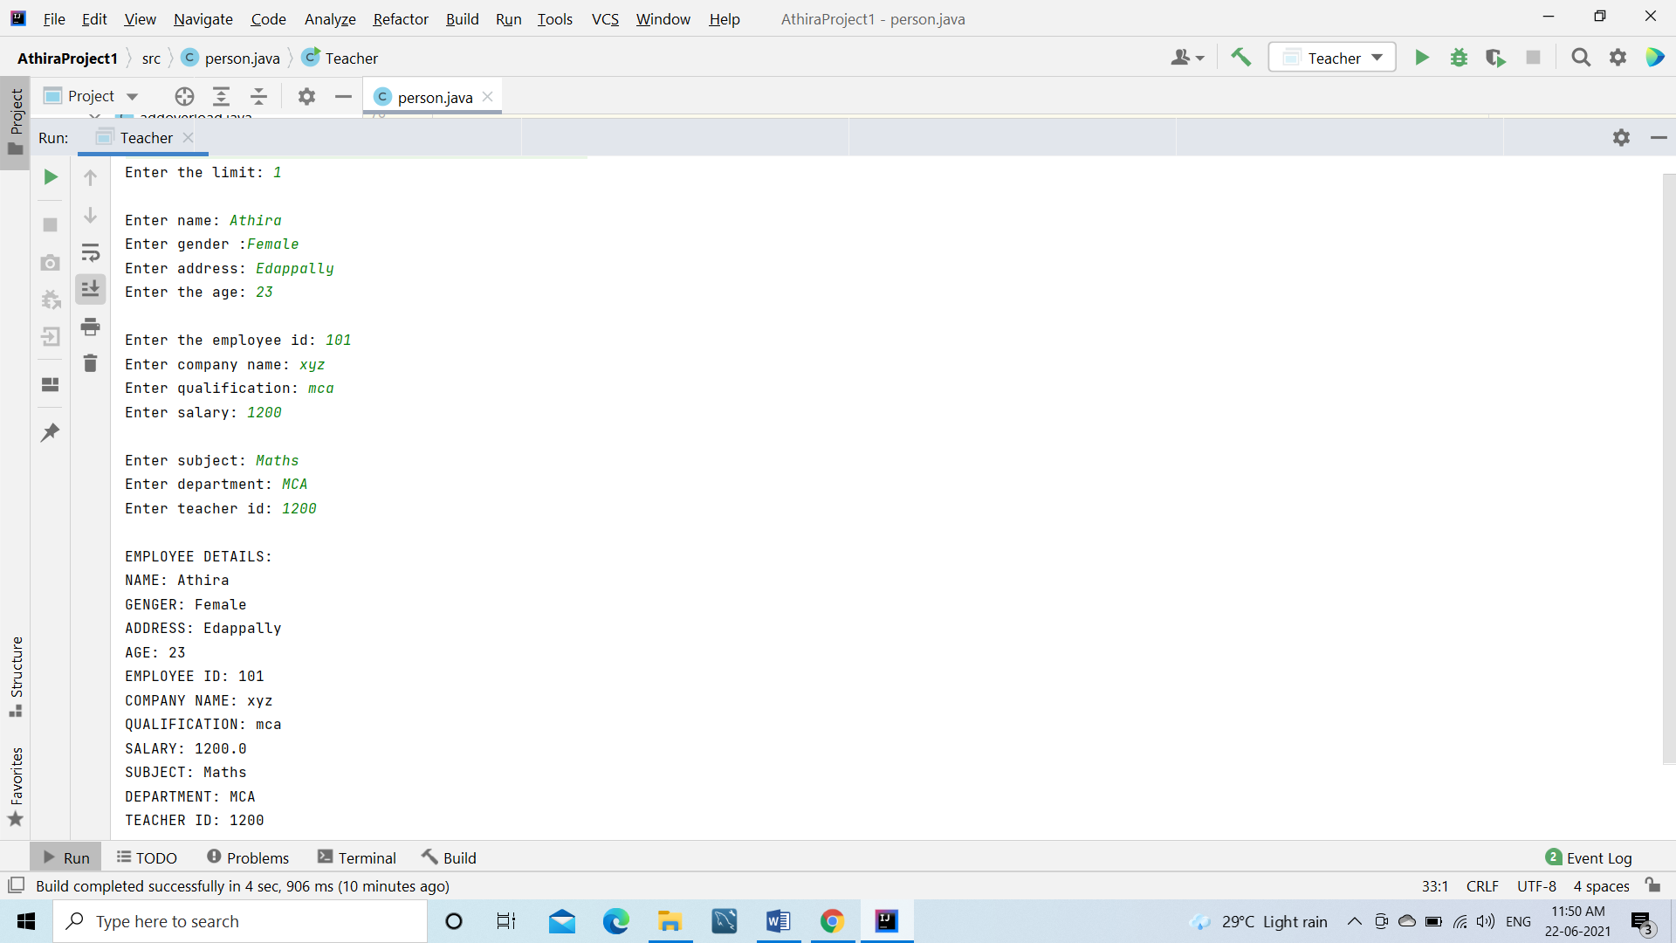

24.Class publisher,book,fiction,literature

Aim: Write a program that has class Publisher, Book, Literature and Fiction. Read the information and print the details of books from either the category, using inheritance.

Code:

import java.util.Scanner;  
public class publisher {  
  
 Scanner reader=new Scanner(System.*in*);  
 String name;  
 public publisher(){  
 name=" ";  
 }  
 public void input(){  
 System.*out*.print("Enter publisher name: ");  
 name=reader.next();  
 }  
}  
class book extends publisher {  
 String bname;  
 int bid;  
  
 public book() {  
 bname = " ";  
 bid = 0;  
 }  
  
 public void binput() {  
 System.*out*.print("Enter book id: ");  
 bid = reader.nextInt();  
 System.*out*.print("Enter book name: ");  
 bname = reader.next();  
  
 }  
}  
class fiction extends book{  
 String fic;  
 public fiction(){  
 fic=" ";  
 }  
 void finput(){  
 System.*out*.print("Specify fiction or non fiction: ");  
 fic=reader.next();  
 }  
}  
class literature extends book {  
 String lit;  
  
 public literature() {  
 lit = " ";  
 }  
  
 void linput() {  
 System.*out*.print("Enter type of literature: ");  
 lit = reader.next();  
 }  
  
 public static void main(String[] args) {  
 literature i = new literature();  
 fiction f=new fiction();  
 i.input();  
 i.binput();  
 f.finput();  
 i.linput();  
 System.*out*.println("\nBOOK DETAILS: ");  
 System.*out*.println("Publisher name: " + i.name);  
 System.*out*.println("Book id: " + i.bid);  
 System.*out*.println("Book name: " + i.bname);  
 System.*out*.println("Fiction or non-fiction: " + f.fic);  
 System.*out*.println("Literature type: " + i.lit);  
  
 }  
}

Output:

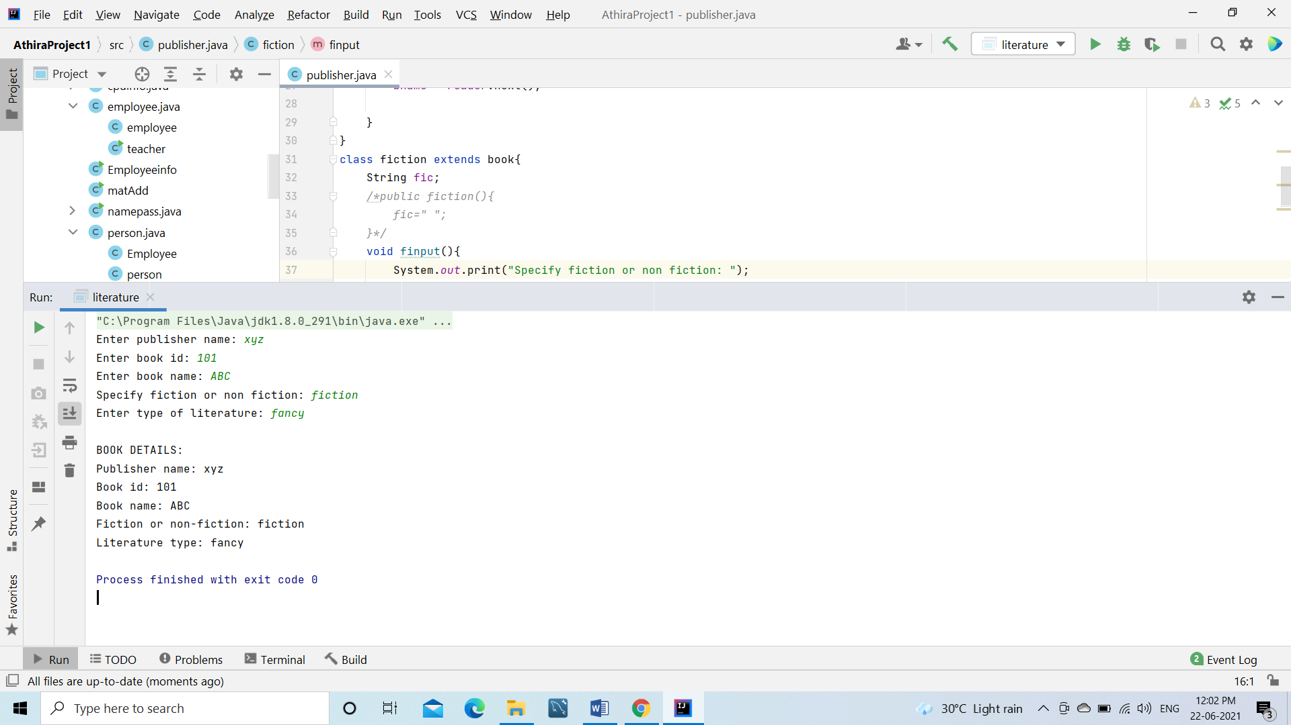

25.Classes student,sports and result

Aim:Create classes Student and Sports. Create another class Result inherited from Student and Sports. Display the academic and sports score of a student.

Code:

import java.util.Scanner;  
  
interface sports {  
 *// float smark=0;* void sinput();  
 void soutput();  
  
}  
class student {  
 Scanner reader=new Scanner(System.*in*);  
 int rolln;  
 float amark;  
 student(){  
 rolln=0;  
 amark=0;  
 }  
 void stinput(){  
 System.*out*.print("Enter roll number: ");  
 rolln=reader.nextInt();  
 System.*out*.print("Enter academic mark: ");  
 amark=reader.nextFloat();  
 }  
 void stoutput(){  
 System.*out*.println("\nRoll number: "+rolln);  
 System.*out*.println("Academic mark: "+amark);  
 }  
}  
  
class result extends student implements sports{  
 Scanner reader=new Scanner(System.*in*);  
 float tot,smark;  
 public void sinput(){  
 System.*out*.print("Enter sports mark: ");  
 smark = reader.nextFloat();  
 }  
 public void soutput() {  
  
 System.*out*.println("Sports mark: "+smark);  
 tot=amark+smark;  
 System.*out*.println("Total mark: "+tot);  
 }  
}  
class studinheritence{  
 public static void main(String[] args){  
 result r=new result();  
 r.stinput();  
 r.sinput();  
 r.stoutput();  
 r.soutput();  
 }  
}

Output:

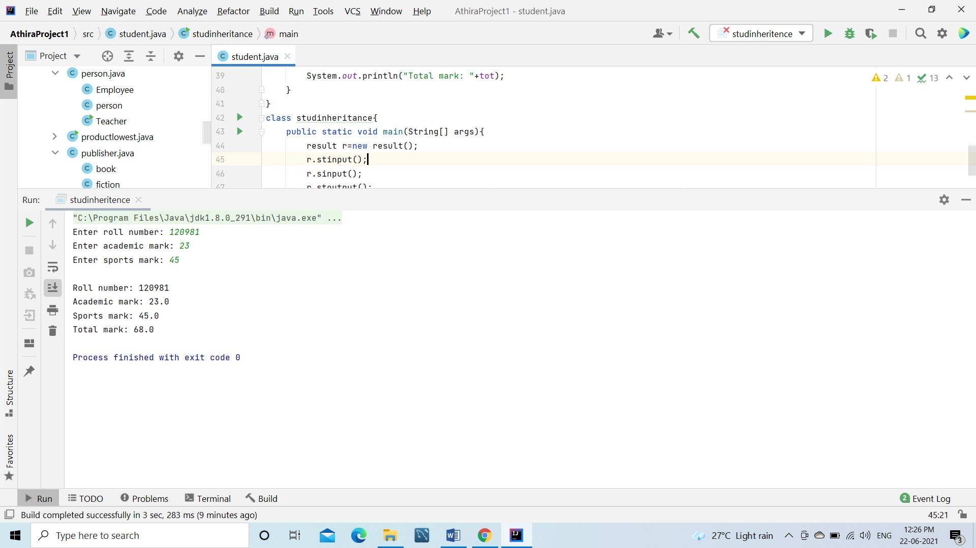

26.Interface

Aim: Create an interface having prototypes of functions area() and perimeter(). Create two classes Circle and Rectangle which implements the above interface. Create a menu driven program to find area and perimeter of objects.

Code:

import java.util.Scanner;  
interface obj {  
 double *pi*=3.14;  
 void area(double x,double y);  
 void peri(double x,double y);  
 void area(double x);  
 void peri(double x);  
}  
class rect implements obj{  
 @Override  
 public void area(double x, double y) {  
 System.*out*.print ("Area of rectangle is: "+(x*y));  
 }  
 public void peri(double x,double y){  
 System.*out*.print ("Perimeter of rectangle is: "+(2*(x+y)));  
 }  
 public void area(double x){ }  
 public void peri(double x){ }  
}  
class cir implements obj{  
 public void area(double x){  
 System.*out*.print ("Area of circle is: "+(*pi*\*x*x));  
 }  
 public void peri(double x){  
 System.*out*.print ("Circumference of circle is: "+(2\**pi*\*x));  
 }  
 public void area(double x, double y) {}  
 public void peri(double x, double y) {}  
}  
class interfacearea{  
 public static void main(String arg[]){  
 rect r=new rect();  
 cir c=new cir();  
 int choice;  
 double l,b,s;  
 Scanner reader = new Scanner(System.*in*);  
 System.*out*.print("\nMENU \n1. Area of rectangle \n2.Area of circle \n3.Perimeter of rectangle \n4.Perimeter of circle \nEnter your choice:\n");  
 choice= reader.nextInt();  
 switch (choice)  
 {  
 case 1: System.*out*.print("Enter the length and breadth of rectangle: ");  
 l=reader.nextDouble();  
 b=reader.nextDouble();  
 r.area( l, b);  
 break;  
 case 2: System.*out*.print("Enter the radius of circle: ");  
 s=reader.nextDouble();  
 c.area(s);  
 break;  
 case 3: System.*out*.print("Enter the length and breadth of rectangle: ");  
 l=reader.nextDouble();  
 b=reader.nextDouble();  
 r.peri( l, b);  
 break;  
 case 4: System.*out*.print("Enter the radius of circle: ");  
 s=reader.nextDouble();  
 c.peri(s);  
 break;  
 default:System.*out*.print("Invalid choice");  
 }  
 }  
}

Output: